CLOUD COMPUTING LAB

Name: Maria Abdul Malik
Reg No: 2023-BSE-076
Submitted to: Sir Muhammad Shoaib
Class: 5B
LAB #05
Task 1 - Discover missing command & install Java using apt suggestion
task1_java_install.png
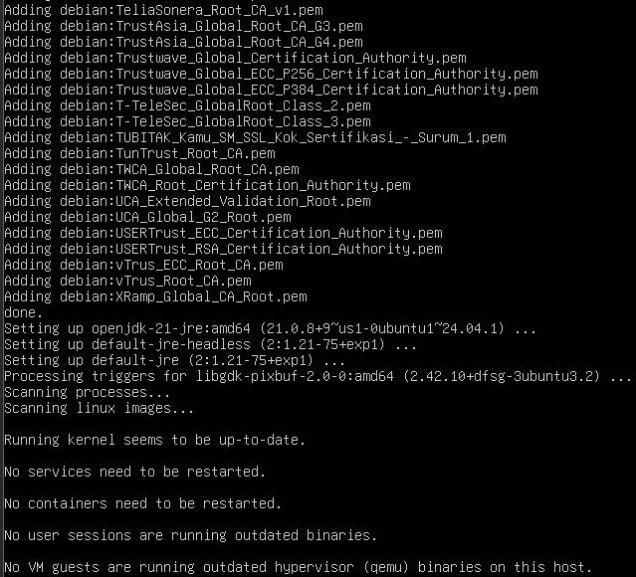
task1_java_version.png
task1_java_remove.png
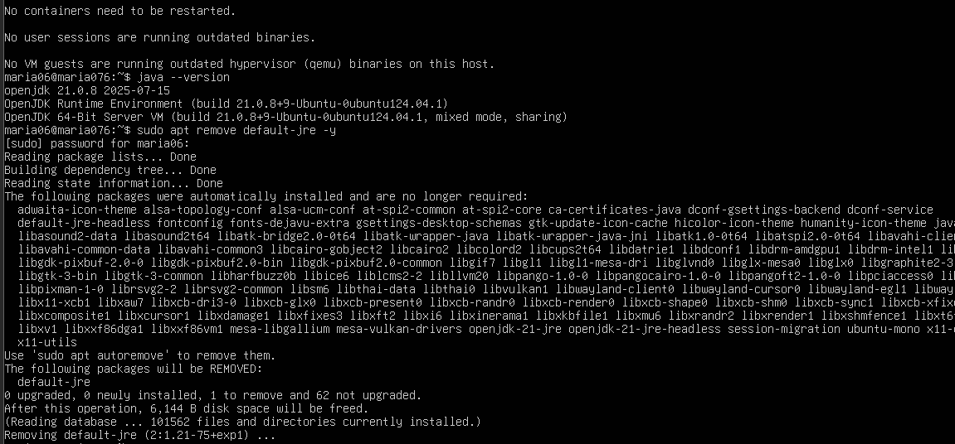
task1_hash_clear.png
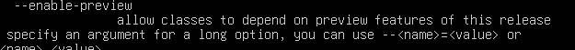
Task 2 - Install & remove Java using apt-get (explicitly)
Task2_aptget_install.png
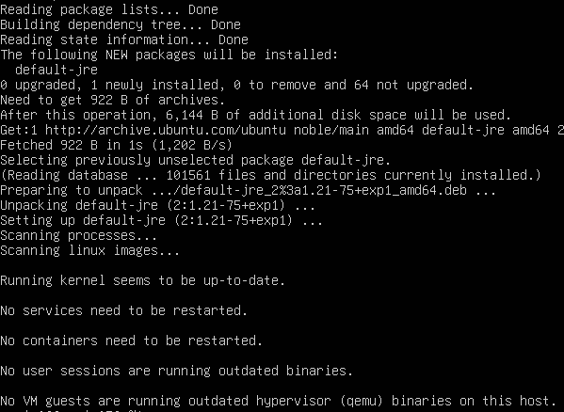
Task2_java_version_after_aptget.png
Task2_aptget_remov.png
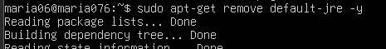
task2_hash_after_remove.png
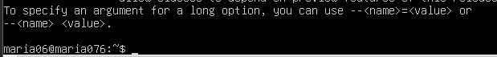
Task 3 - apt update vs apt upgrade - run & explain
task3_apt_update.png
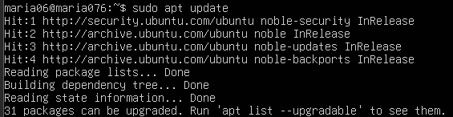
task3_apt_upgrade.png
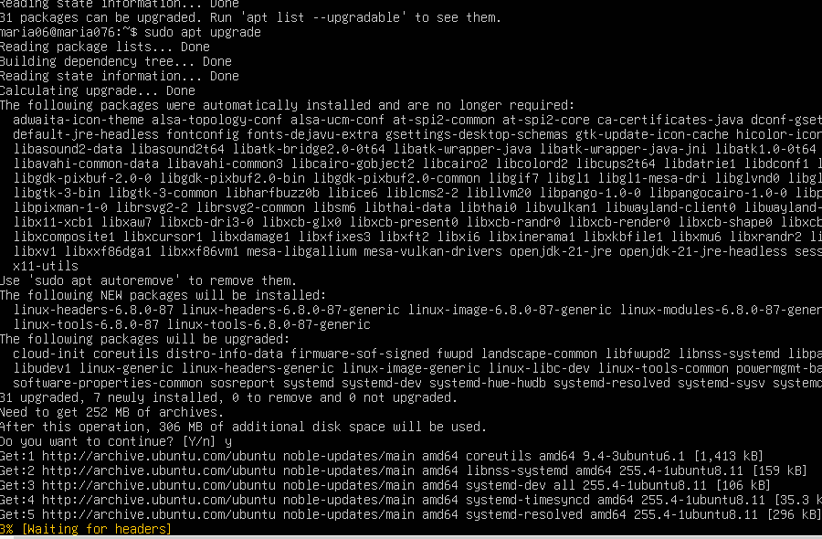
Task 4 - Install Visual Studio Code via snap on CLI and verify (DO NOT remove Code)
task4_snap_install.png
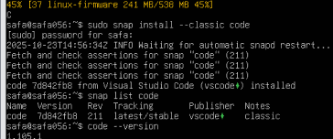
task4_snap_list.png
task4_code_version_or_info.png
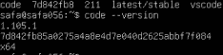
task4_snap_bin_location.png
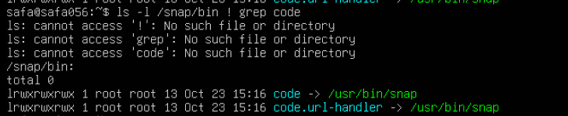

Task 5 - Install XFCE GUI + XRDP - minimal desktop and remote access (GUI) and launch VS Code
task5_update.png
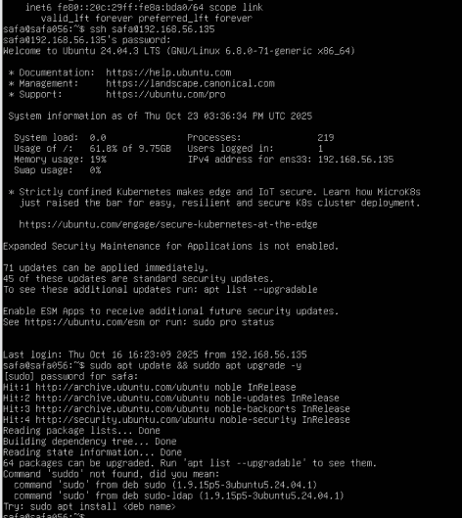
task5_xfce_install.pn
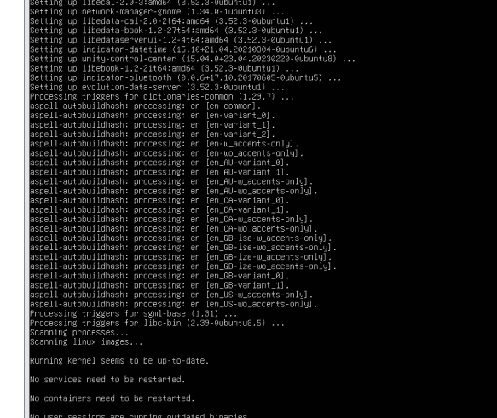
task5_xrdp_enable.png
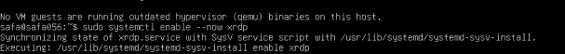
task5_xrdp_status.png
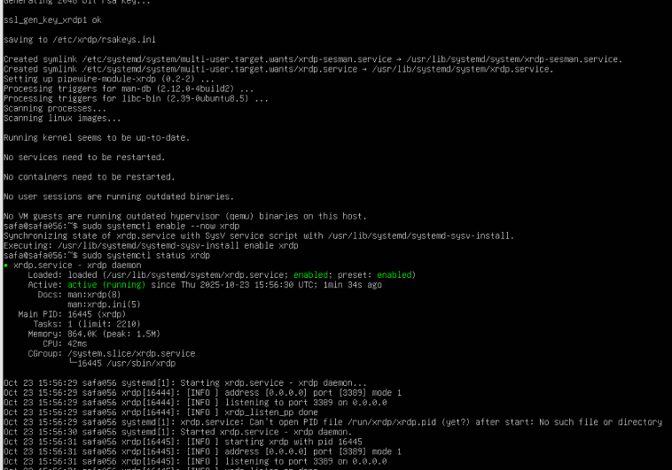
task5_xsession.png
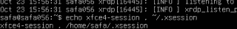
task5_rdp_connect.png
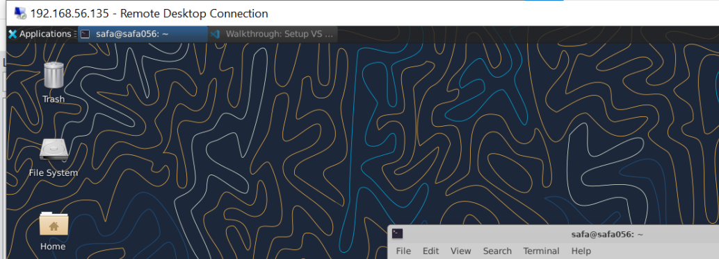
task5_vscode_launch.png
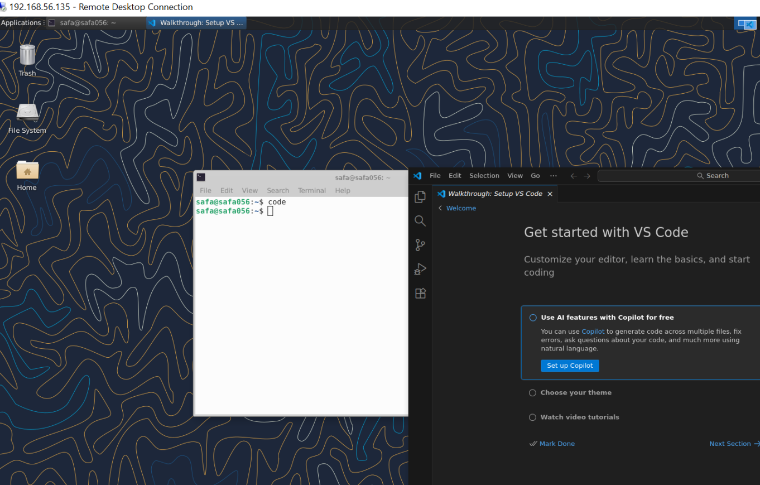

Task 6 - Install lightdm-gtk-greeter and GUI verification - start GUI, open VS Code, take snapshot, then end (GUI)
task6_lightdm_install.png
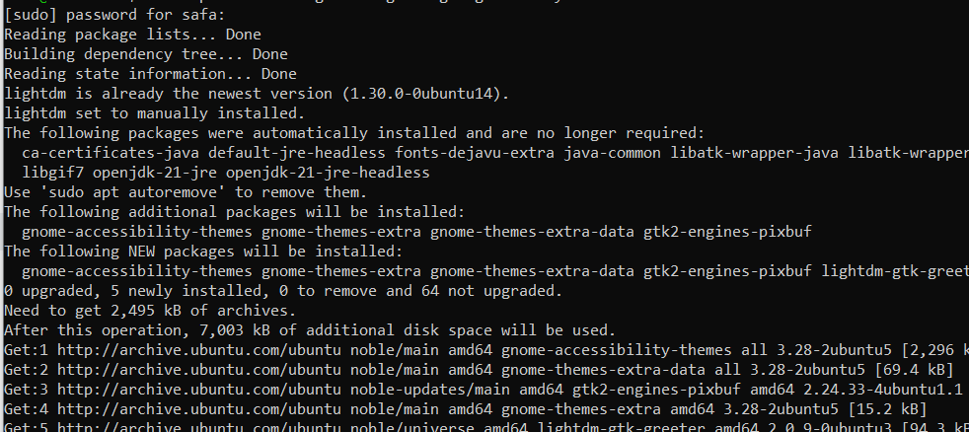
task6_lightdm_config.png
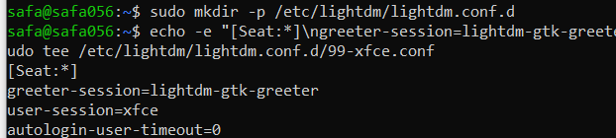
task6_lightdm_cleanup.png
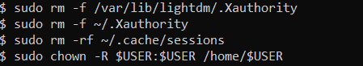
task6_lightdm_restart.png
task6_gui_enable_boot.png
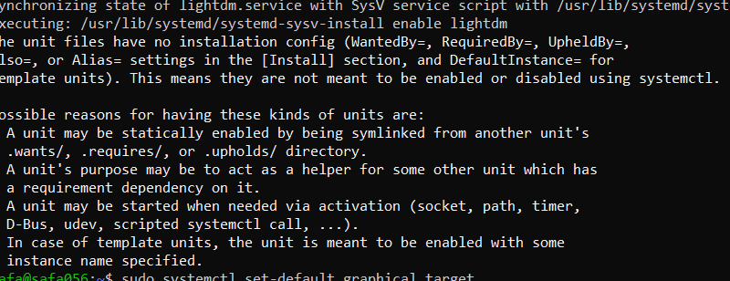
task6_after_reboot_gui.png
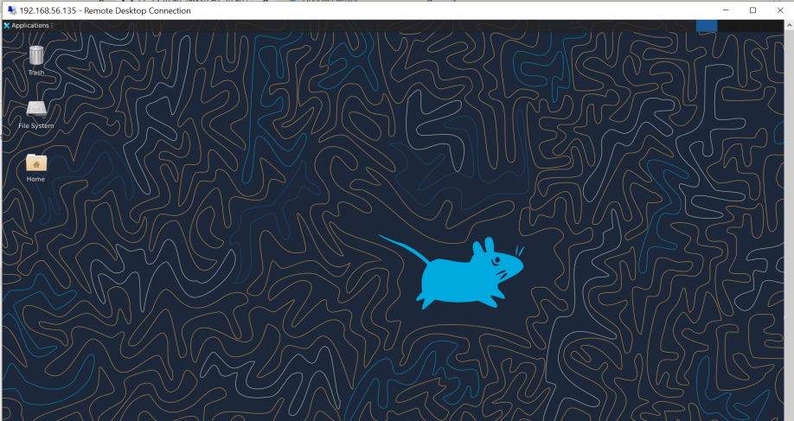
task6_after_reboot_cli.png
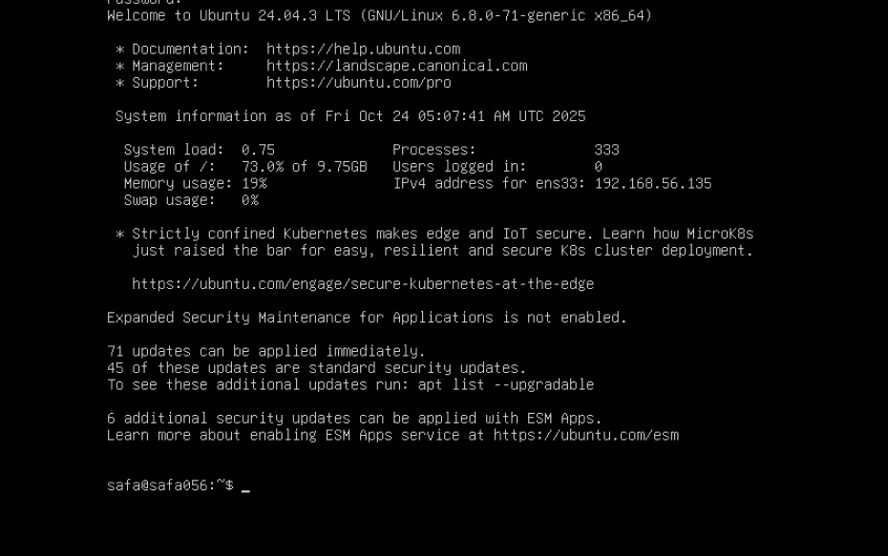
task6_gui_start.png
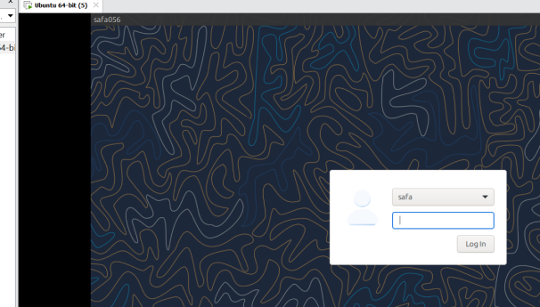
task6_gui_stop.png
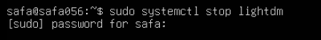
task6_gui_start_command.png
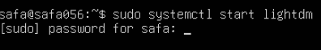
task6_vscode_launch.png
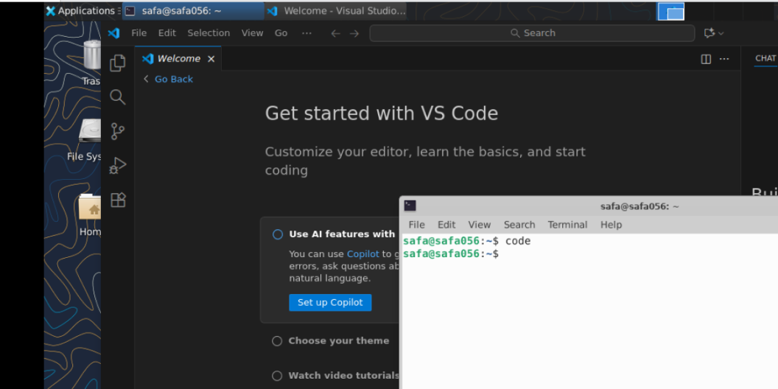

Task 7 - Install Google Chrome by adding its apt source & key (Chrome)
task7_install_chrome_error.png
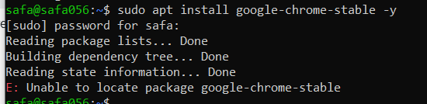
task7_ls_etc_apt.png
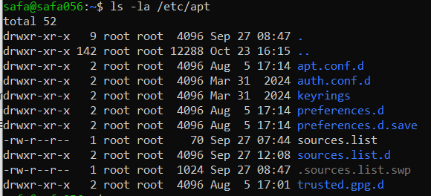
task7_cat_sources_list.png
task7_ls_sources_list_d.png
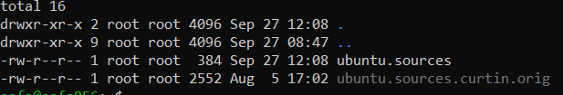
task7_cat_ubuntu_sources.png
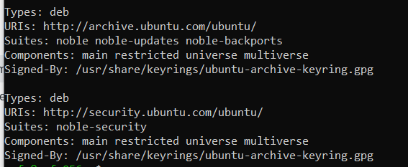
task7_edit_ubuntu_sources.png
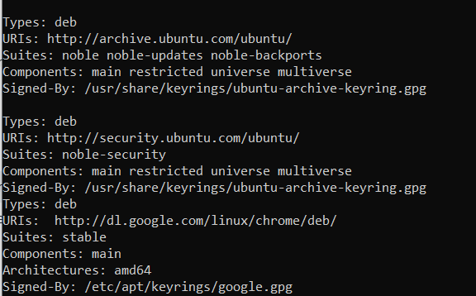
task7_add_key.png
task7_apt_update.png
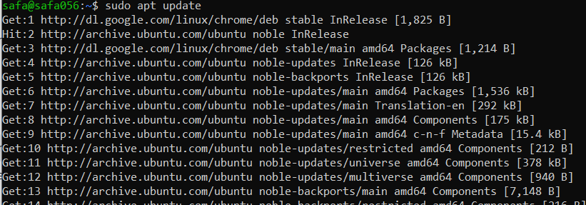
task7_install_chrome.png
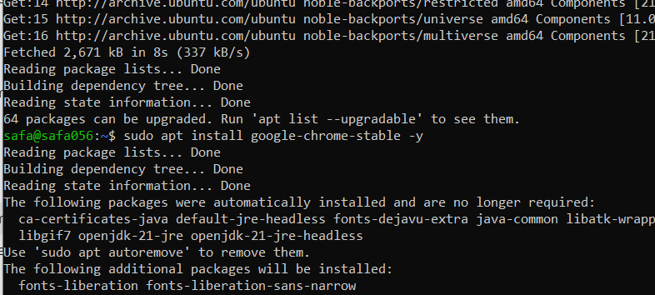
task7_alternate_remove.png
task7_alternate_edit.png
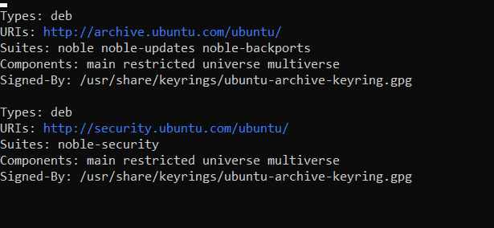
task7_remove_key.png
task7_create_google_chrome_list.png
task7_list_sources_after_create.png
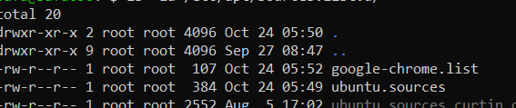
task7_add_key_alt.png
task7_apt_update_alt.png
task7_install_chrome_alt.png
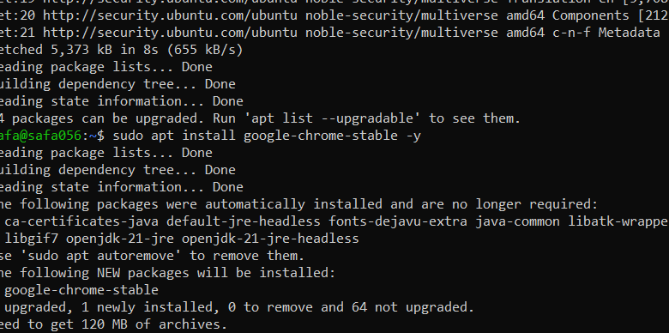

Task 8 - Install applications via PPA (Audacity & OBS) and launch
task8_add_ppa_audacity.png
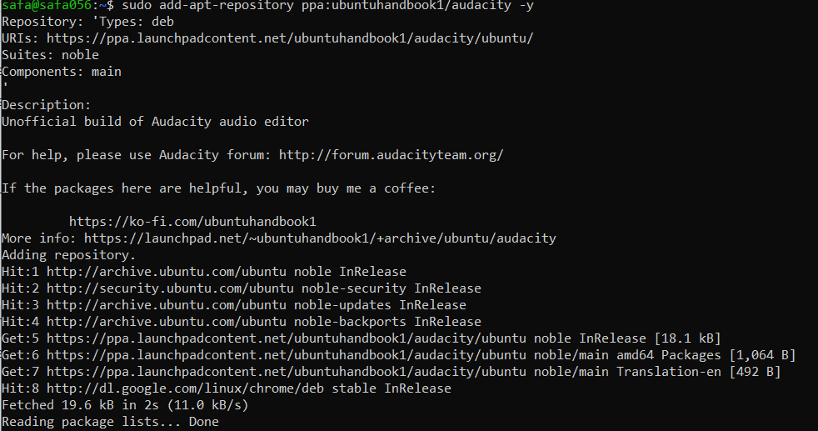
task8_apt_update_audacity.png
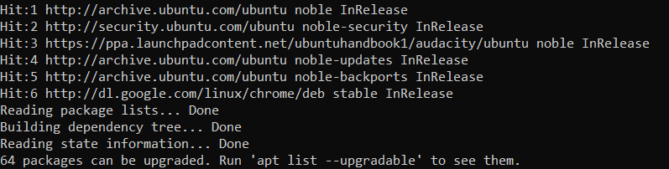
task8_install_audacity.png
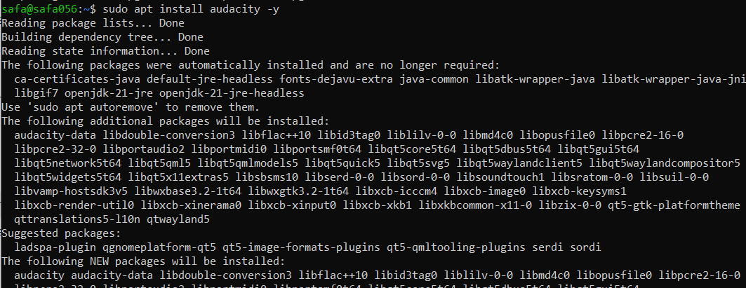
task8_audacity_launch.png or task8_audacity_version.png
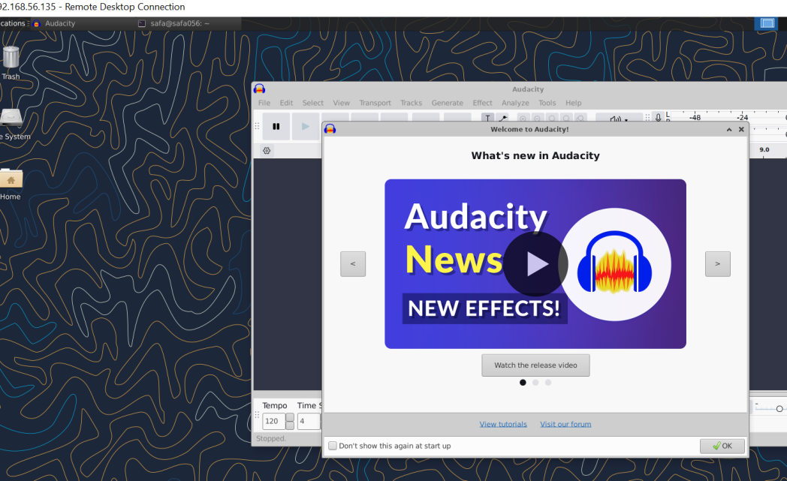
task8_add_ppa_obs.png
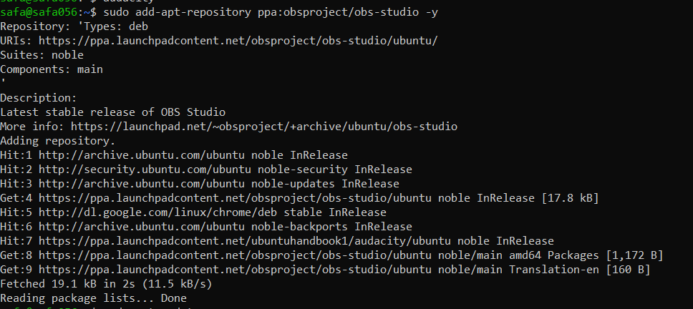
task8_apt_update_obs.png
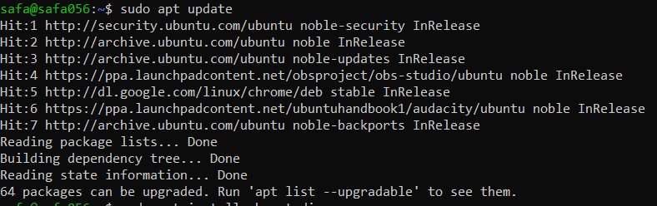
task8_install_obs.png
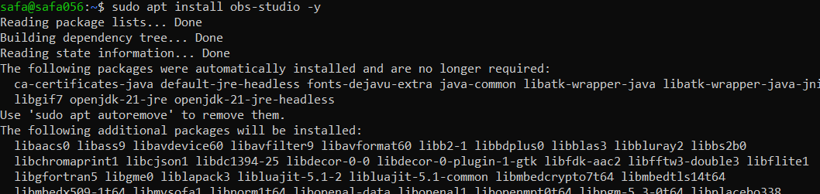
task8_obs_launch.png or task8_obs_version.png
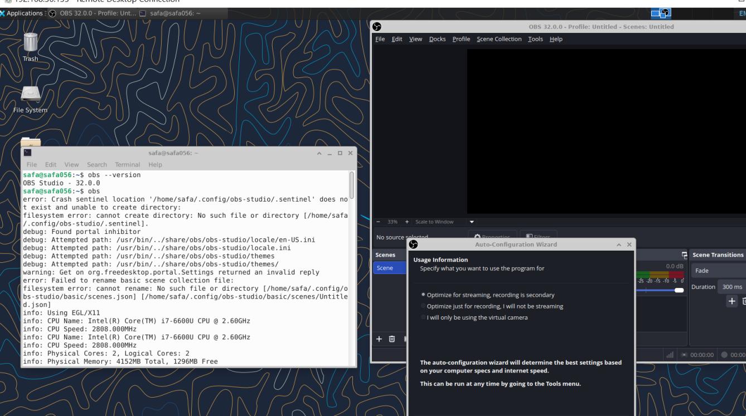

Task 9 - Create a Kubernetes sample YAML using vim
task9_vim_check.png
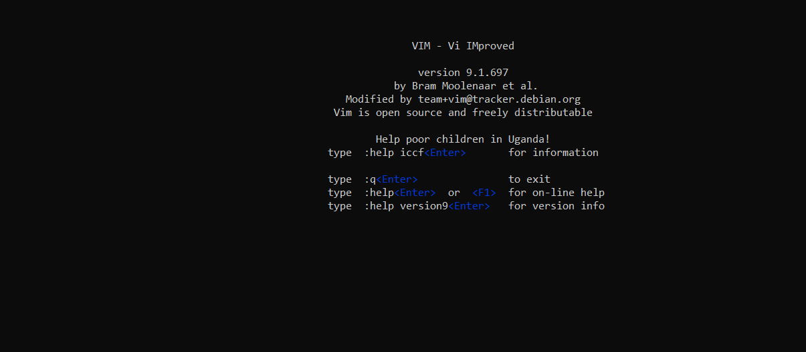
task9_vim_edit.png
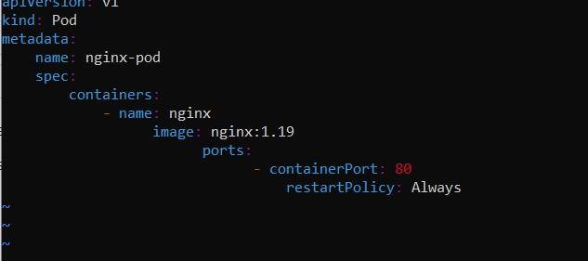
task9_k8s_saved.png
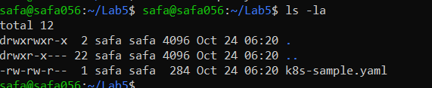

Task 10 - Edit the Kubernetes YAML - add annotation, verify, then discard temporary change
task10_verify_annotation.png
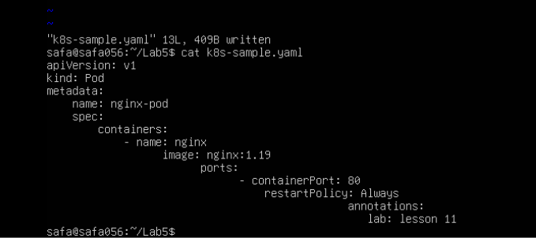
task10_verify_entering_temp_data.png
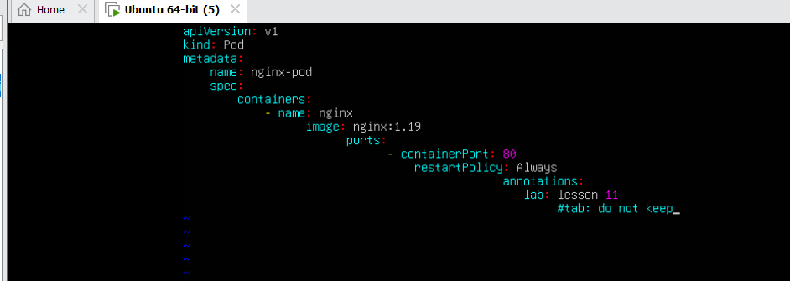
task10_verify_no_temp_comment.png
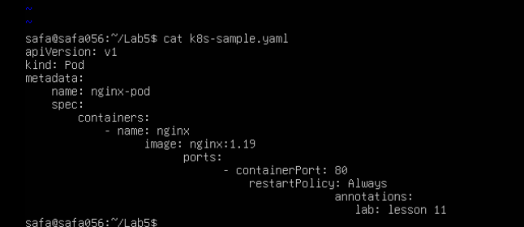

Task 11 - Vim editing practice - delete, undo, numeric deletes, and navigation
task11_dd_delete_and_undo.png
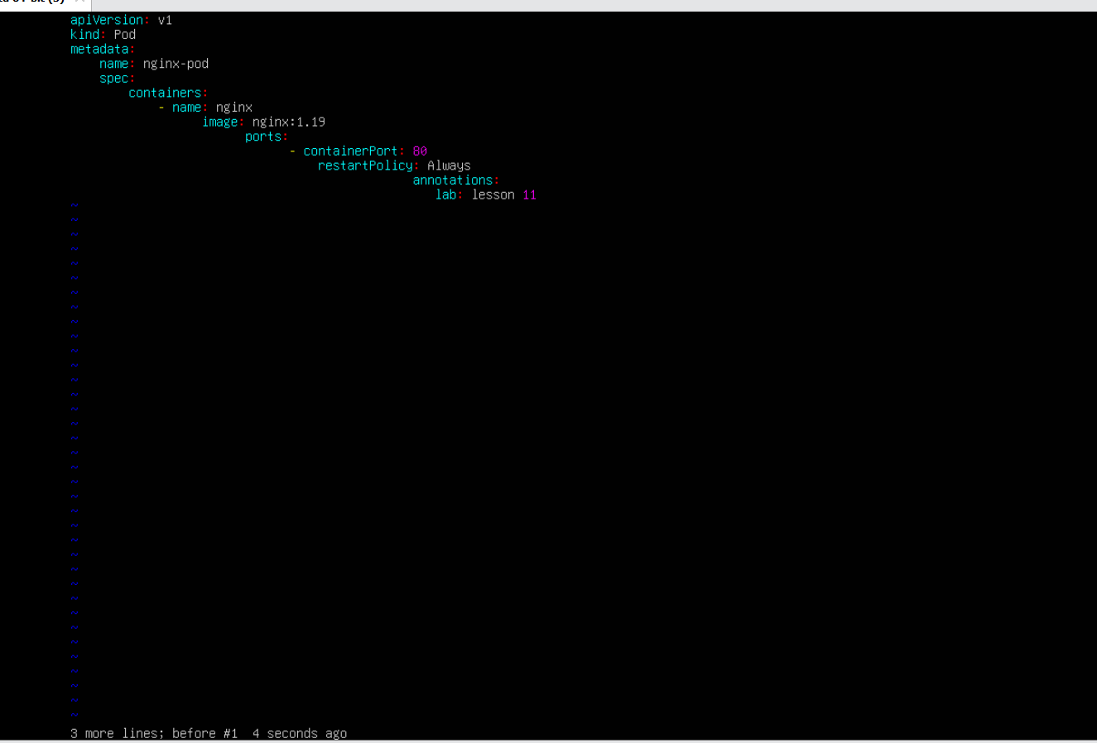
task11_delete3_and_undo.png
task11_line1.png
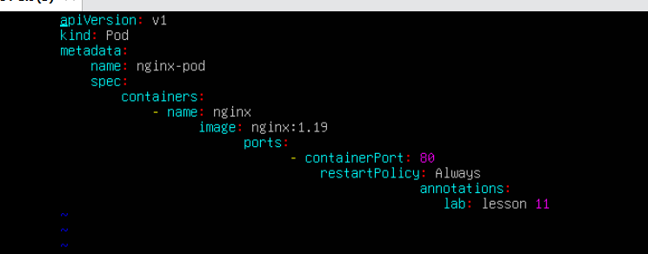
task11_navigation.png
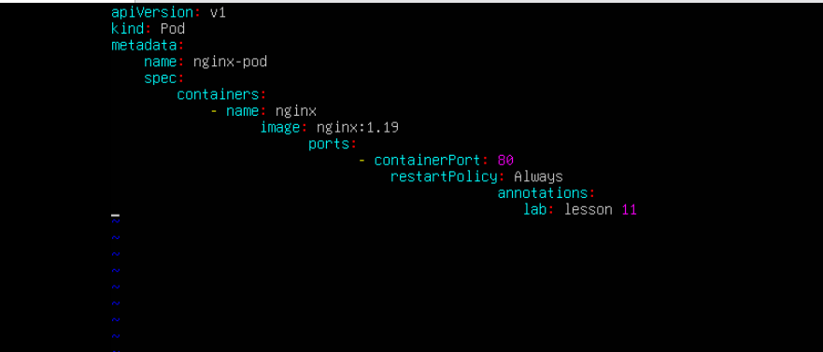

Task 12 - Vim search, add matches, substitute, undo
task12_search_nginx.png
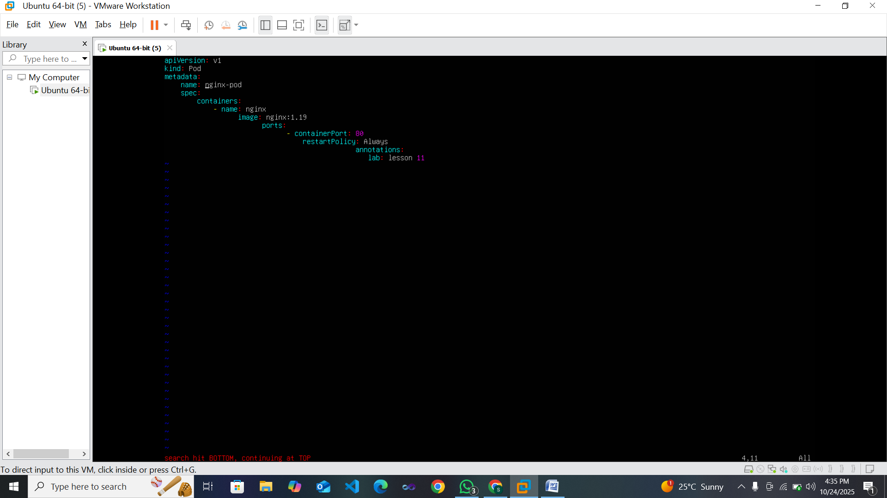
task12_n_and_N_navigation.png
task12_added_occurrences.png
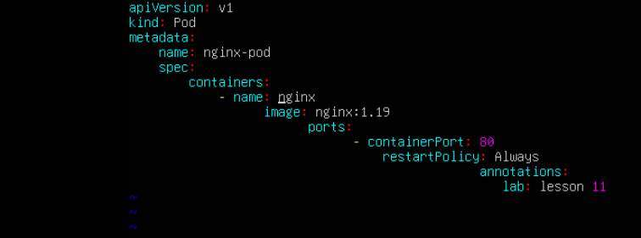
task12_cycle_matches.png
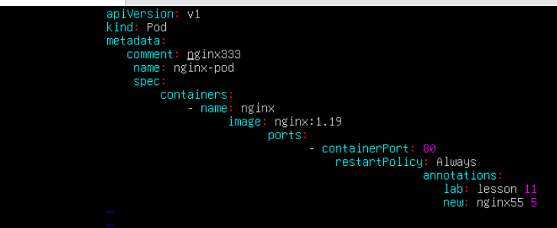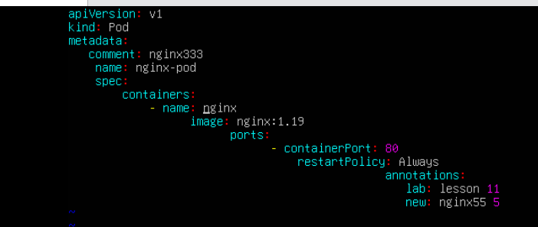
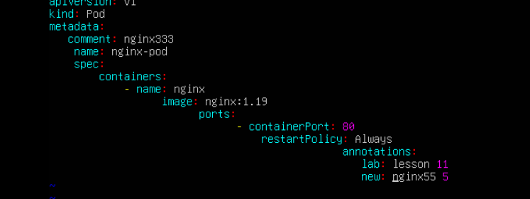
task12_substitute_result.png
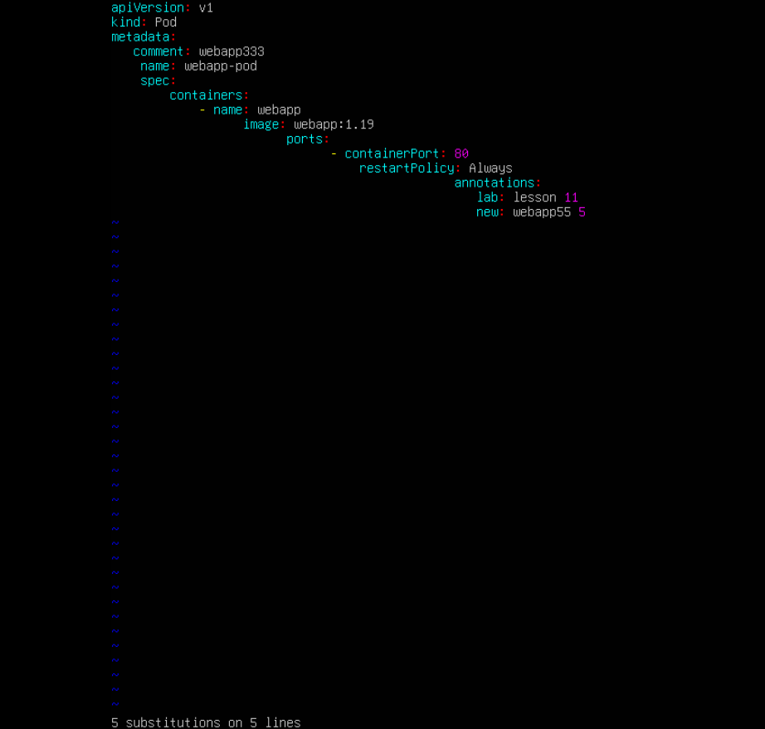
task12_undo_and_quit.png
